Independent-Samples t-Test – Example 1 (Statistics Learning)

I predict that students who learn to calculate statistics by hand are better able to select the appropriate statistical test to use than students who learn to calculate statistics using SPSS. After teaching students using these two methods, I obtained the quiz scores below.

Step 1. State your hypotheses.
a. Is it a one-tailed or two-tailed test?

b. Research hypotheses
H_{A}:

H₀:

c. Statistical hypotheses
H_{A}:

H₀:

Step 2. Set the significance level ➔ α = .05 Determine t_{crit}. t_{crit} =

Step 3. Compute the appropriate statistical test.

SS₁ = SS₂ =
Hand-Calculation Scores  (X₁) |  | X – | (X –)²
8
7
10
9
8
ΣX = |  |  | SS = Σ(X –)² =
=

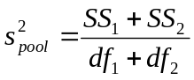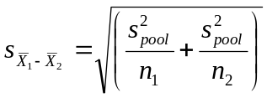

SPSS Scores  (X₂) |  | X – | (X –)²
6
5
7
8
6
ΣX₂ = |  |  | SS = Σ(X –)² =
=

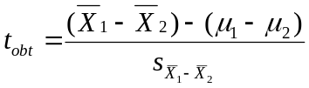

Step 4. Make a decision. Determine whether the value of the test statistic is in the critical region. Draw a picture.
Is t_{obt} in the critical region?
Should you reject or retain the H₀?

Step 5. Report the statistical results.

Step 6. Write a conclusion.

Step 7. Compute the estimated d.
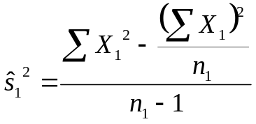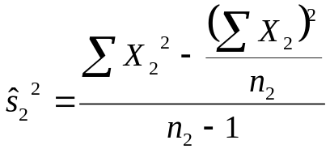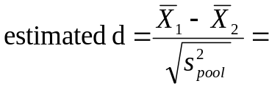
d Effect Size
0.2 Small effect
0.5 Medium effect
0.8 Large effect

Step 8. Compute r² and write a conclusion.

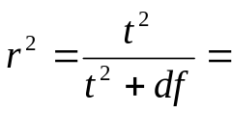 r2 Percentage of Variance Explained
0.01 Small effect
0.09 Medium effect
0.25 Large effect

